**Lab 08**

Submitted by**:**

**Maaz Habib**

Registration Number**:**

**20PWCSE1952**

Section:

**C**

Submitted To**:**

**Dr. Muniba Ashfaq**

January 31, 2024

**Department of Computer System Engineering**

**University of Engineering and Technology Peshawar**

**Task 1:**

Design a system in Simulink where transfer function is :

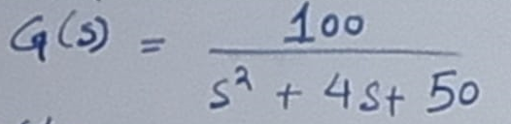

Input signal = unit step signal

Simulation time = 8 sec

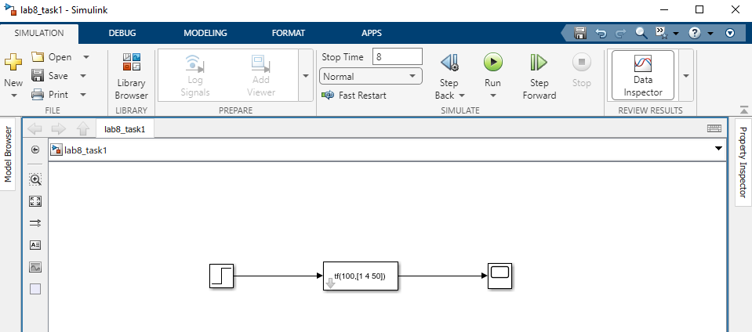

**Task 2:**

Design 3 systems with complex poles such that one system is stable ,unstable and marginally stable.

1. STABLE:

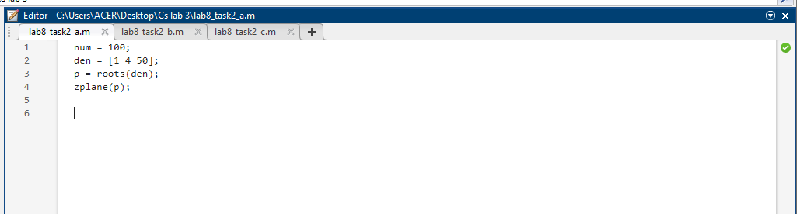

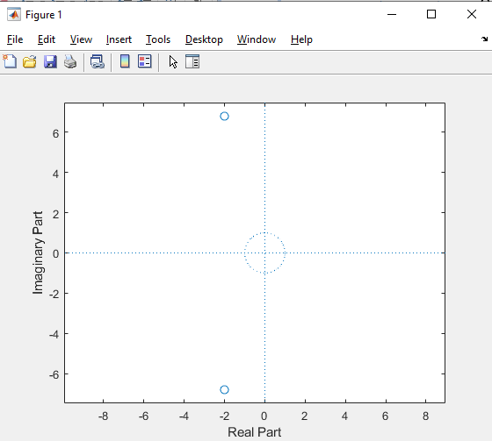

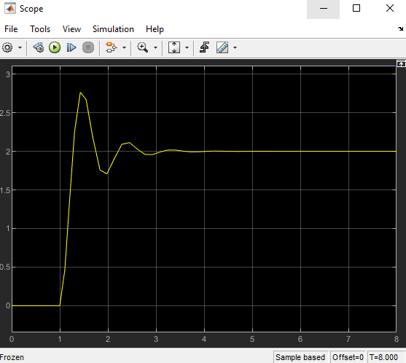

1. UNSTABLE:

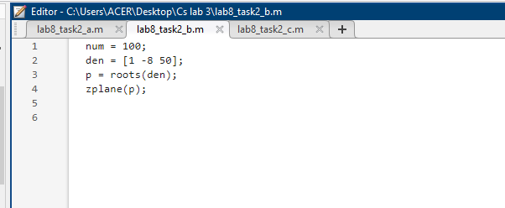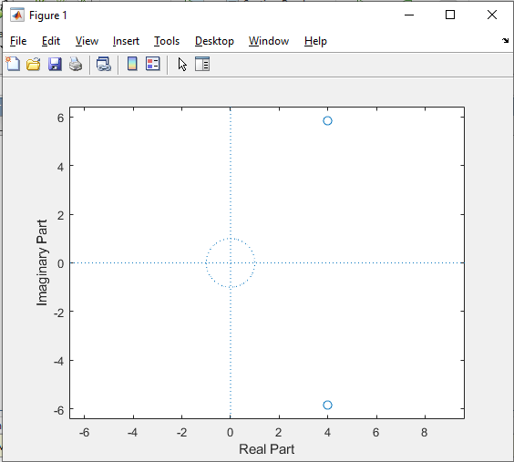

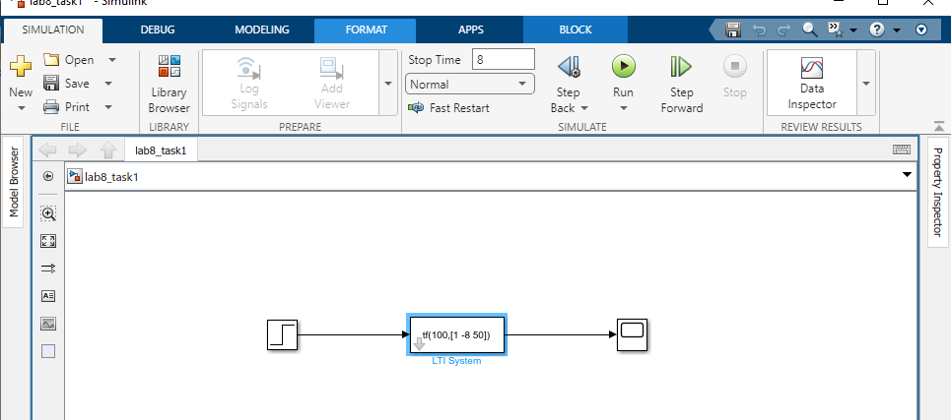

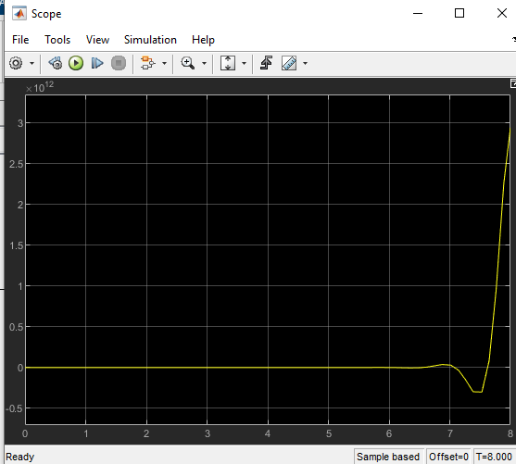

1. MARGINALLY STABLE:

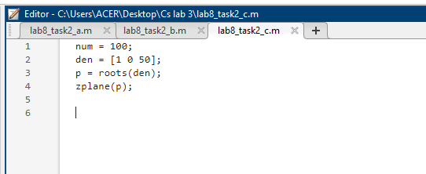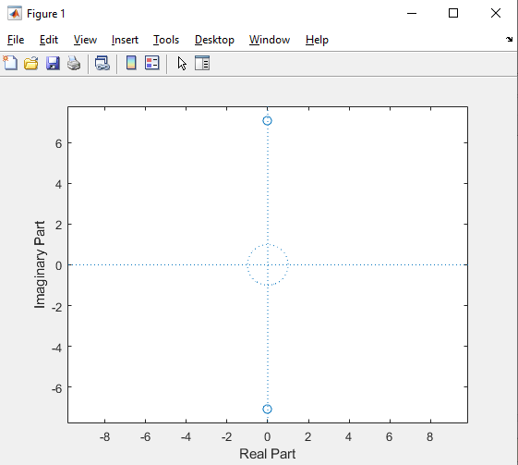

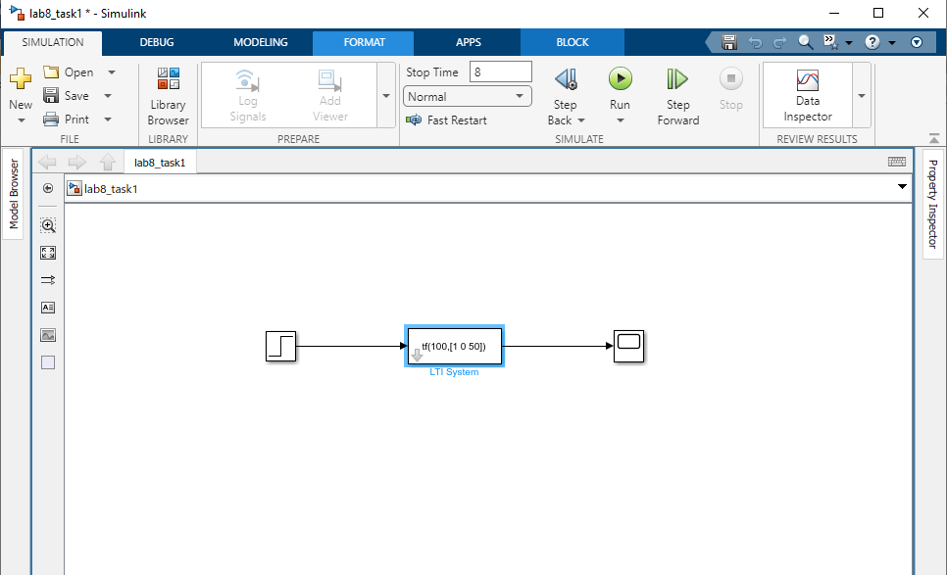

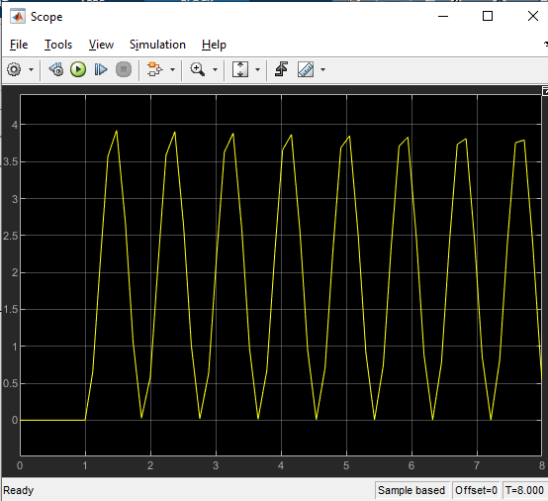

**TASK#03**

ANALYZE :

